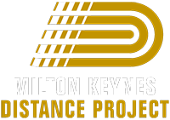
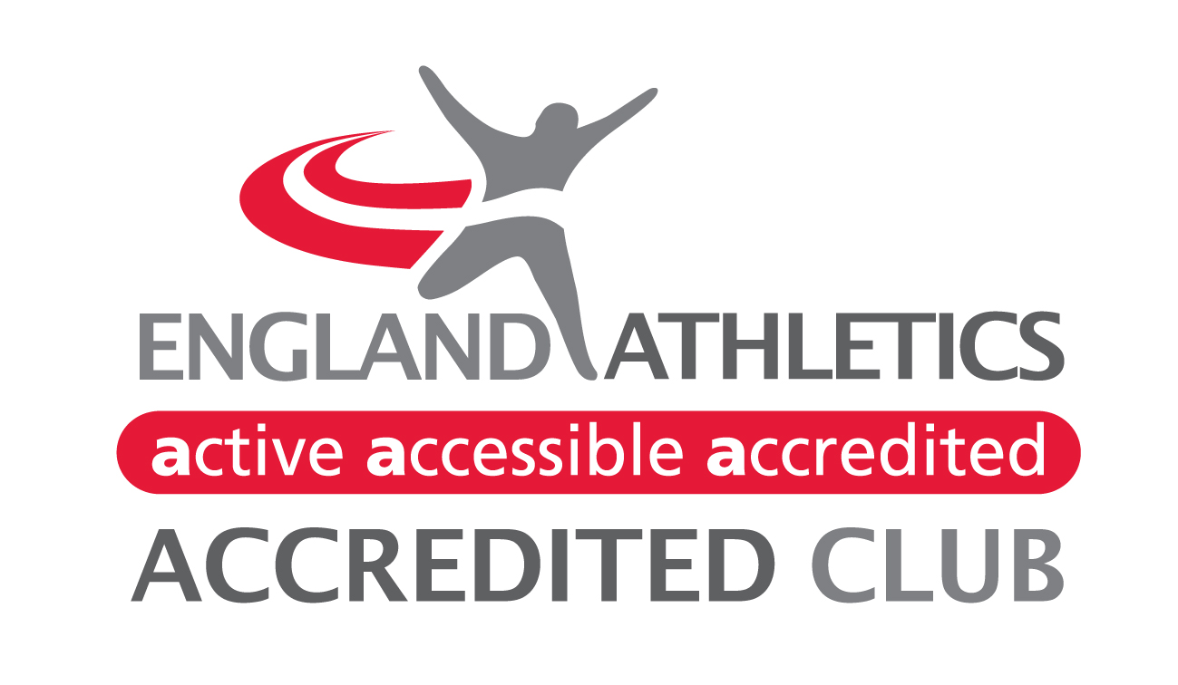

MEMBERSHIP APPLICATION FORM 2024
I wish to become a member of Milton Keynes Distance Project and agree to abide to the Club’s code of conduct and constitution. When you become a member, or renew, we will provide England Athletics with your personal data which they will use to enable access to an online portal for you (called myAthletics). If you have any questions about the use of your personal data when it is shared with EA, please contact dataprotection@englandathletics.org.
First Names |  |  |  |  |  |  |  | Surname
Date of Birth |  |  |  |  |  | Disabled |  | Yes / No |  |  | Gender |  |  |  |  | Male / Female
Nationality |  |  |  |  |  | Ethnic Origin (optional)
Address
 |  |  |  |  |  |  |  |  |  |  | Post Code
Phone Number (home) |  |  |  |  |  |  | Email Address
Have you previously been registered with England Athletics |  |  |  | Yes / No |  |  |  | (If YES please provide EA registration number)
Emergency Contact Details:
Name
Phone Number (mobile) |  |  |  |  |  |  | Email Address
Membership Type and Fee (ONE applies to every member):  Reduced fees for new members only |  |  |  |  |  |  |  |  | Tick | Annual Fee (£) |  |  |  | Join  after 31/3 |  |  | Join  after 30/6 | Join  after 30/9
Individual Member |  |  |  |  |  |  |  |  |  | 120 |  |  |  | 90 |  |  | 60 | 30
Student in Higher Education studying/living away from home |  |  |  |  |  |  |  |  |  | 60 |  |  |  | 40 |  |  | 30 | 20
Family Membership – all from the same address |  |  |  |  |  |  |  |  |  | 240 |  |  |  | 180 |  |  | 120 | 60
Non-Competing Volunteer / Coach / Official |  |  |  |  |  |  |  |  |  | 0 |  |  |  | 0 |  |  | 0 | 0
All payments by bank transfer: |  |  |  |  | Account No: 33484768 |  |  |  |  |  |  |  | Sort Code: 30-98-98
Medical Information: If you answered Yes to the any of the above please provide details below:
Do you have any medical condition(s) Y/N
Can they affect your training and / or competing? Y/N
Publicity and personal data:
The Club promotes its activities on its own website and in the media, as a Member you agree that we may publish your Personal Information as part of the results of any event and confirm that you/your children accept pictures being entered onto the website and any press releases. We may pass such information to the governing body or any affiliated organisation for the purpose of insurance, licences or for publishing results either for the event alone or combined with or compared to other events. Results may include (but not be limited to) name, club, race times, and age category.
Put a cross in the box if you don’t wish your image to be used
Signed Athlete / Parent Consent:
Athlete Name |  |  |  |  |  |  |  |  |  |  |  | Date
Where the athlete is under 18 the parent / guardian must confirm they agree to the athlete taking part in the activities of the Club, will encourage the athlete to comply with all appropriate Codes of Conduct of the Club and England Athletics and also give consent to emergency treatment being given by appropriate personnel.
Parent / Guardian Name |  |  |  |  |  |  |  |  |  |  |  | Date

We welcome you and your family to the Club. To find out all the latest club information, please
visit the Club website: http://www.mkdistanceproject.co.uk
Please note it is preferable to receive this form back via email

